

**The University of Azad Jammu and Kashmir, Muzaffarabad**

**Assignment no: 01**

**Class Diagram of Inheritance in UML**

Name: Saqlain Mushtaq

Roll no: 2024-SE-35

Semester: 2nd

Subject: Object Oriented Programming

Lecturer: Engr, Awais Rathore

Course Code: CS-1204

**Depart:**

**SOFTWARE ENGIMEERNIG**

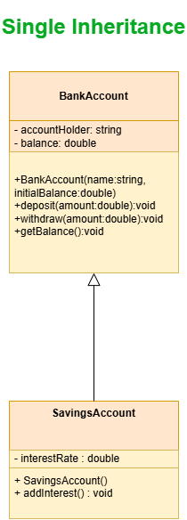

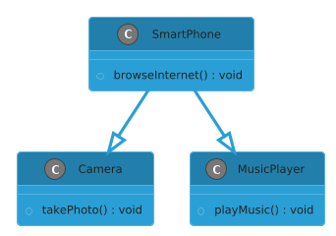**Multi Inheritance**

**Multilevel Inheritance**

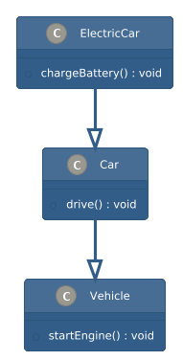

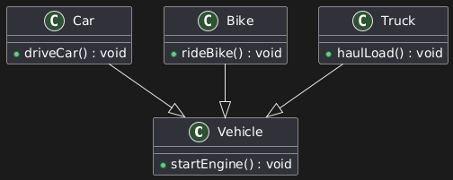**Hierarchical Inheritance**

**Hybrid Inheritance**

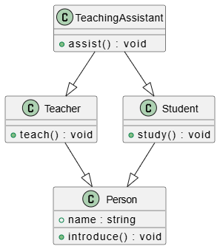

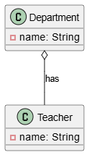**Aggregation**

**Composition**

